COSC3000 – project proposal:

Tony Liao

1. Topic and goal

Topic – **Gravitational analysis of inner and outer planets in solar system**

Goal – The goal of this project is to show the difference gravitational force between all planets in the solar system and relationship between them from the sun.

1. Why this project is interesting?

By analysing gravity, reader can gain insights into the planets ‘orbits in solar system which can help reader to understand their behavior from the aspect of gravitational force.

When comparing the gravitational force of inner and outer planets in solar system can help astronomer to identify the difference or similarity between them.

This can also help astronomer to analysing the gravitational force on different planet. Which can help them to understand how the gravitational force from the sun is differ to other planets.

1. How will this project achieve the goal?

This project will provide the information and visualize techniques such as heat map, interactive visualization, 3d visualization to help audiences understand.

1. What is this project’s data source and how will this project obtain it?

NASA’s planetary fact sheet, see [Planetary Fact Sheet (nasa.gov)](https://nssdc.gsfc.nasa.gov/planetary/factsheet/)

The Jet propulsion laboratory, see [JPL Solar System Dynamics (nasa.gov)](https://ssd.jpl.nasa.gov/)

I will start by look up the data on these sites and research some useful data from it such as distance from sun.

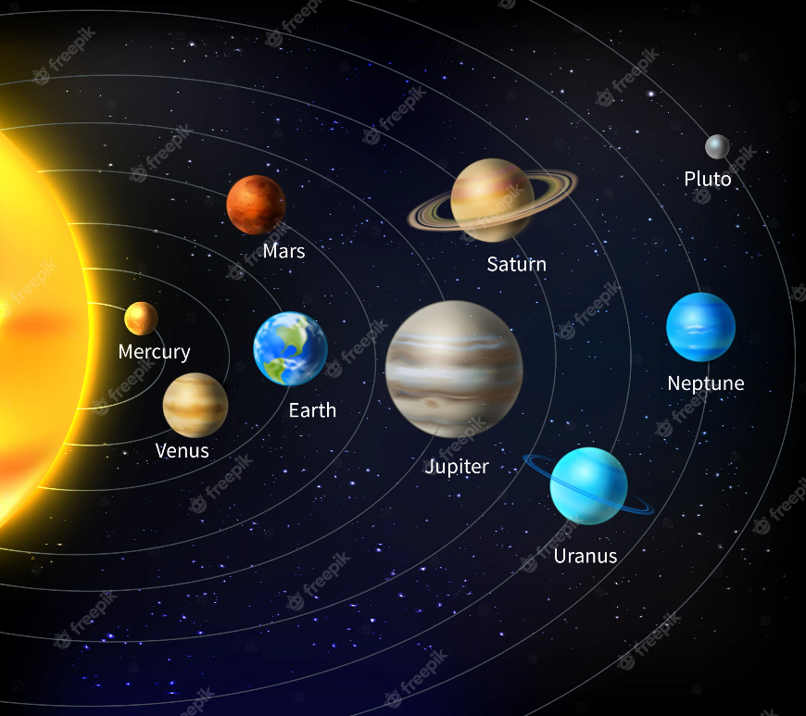

Dataset:

Aim:

AI:

The goal of this project is to analyse the eccentricities of the inner and outer planets in the solar system and investigate the relationship between eccentricity and distance from the sun. To achieve this goal, various data sources such as NASA's planetary fact sheet and the Jet Propulsion Laboratory's solar system dynamics will be utilized. Additionally, this project will incorporate a variety of visualizations such as scatter plots, bar charts, line graphs, and orbital diagrams, as well as more complex visualizations such as heat maps, bubble charts, 3D visualizations, and interactive visualizations to provide a better understanding of the behaviour and relationships of the planets in the solar system.

One resource that provides gravitational force data in JSON format is the NASA Planetary Fact Sheet API, which can be accessed at https://api.le-systeme-solaire.net/. This API provides various data about the planets, including their mass, radius, distance from the sun, and gravitational force, all in JSON format. To access the gravitational force data for a specific planet, you can use the following URL format: https://api.le-systeme-solaire.net/rest/bodies/{planet_name}.json, replacing {planet_name} with the name of the planet in lowercase, without spaces. For example, to get the gravitational force data for Mars, you can use the following URL: https://api.le-systeme-solaire.net/rest/bodies/mars.json.